**Jobsheet-8: PHP - Form Upload, Cookies and Session**

**Web Design and Programming Courses**

Erwan Majid / 08 / 2i

Link Github: <https://github.com/Majid5654/Semester-3/tree/master/Week8>

* **Practical Section 1. Files**

1. Save the file, then open a browser and run localhost/week8/form_upload.php. Select a file and click the Submit button. Observe what happens and record your understanding. (Question No. 1)

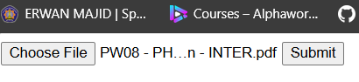

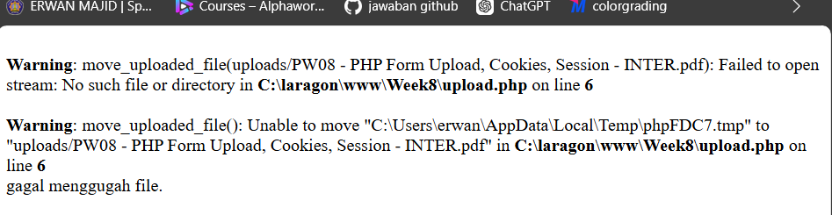

-error because $targetdir = "uploads/";

-is no exist in folder,so that can result error

1. Next, create a folder named uploads in the week8. Re-run localhost/week8/form_upload.php.

Select a file and click the Submit button. Observe what happens and record your understanding. (Question No. 2)

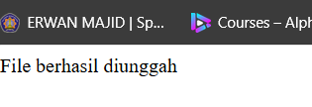

-it because the uploads/ folder is present in your project directory (C:\laragon\www\Week8\uploads).

1. Save the file, open a browser and run localhost/week8/form_upload.php Select a file with the .pdf extension or .docx. Click the Submit button. Observe what happens and record your understanding. (Question No. 3)

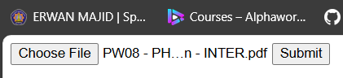

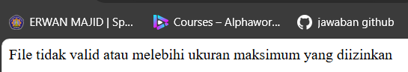

-File Type Check: in_array($fileType, $allowedExtensions) ensures that only files with certain extensions (like jpg, jpeg, png, gif) are allowed

-if the type is allowed,it output File berhasil diunggah

-if not it displays "File tidak valid atau melebihi ukuran maksimum yang diizinkan"

1. Next run localhost/week8/form_upload.php again. Select a file with the extension .jpg, .jpeg, .png, or .gif. Click the Submit button. Observe what happens and record your understanding. (Question No. 4)

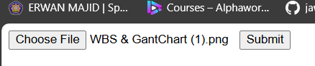

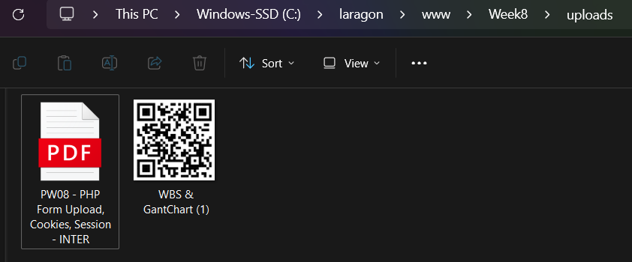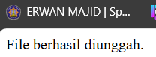

-it says file berhasil diunggah,because meet file criteria ,which png and 5mb max

1. Add script from step 6 to display thumbnail image files with a width of 200 and height following the changes automatically after the image file is successfully uploaded.Screen shoot the additional code. Explain your understanding after adding the program code. (Question No. 5)

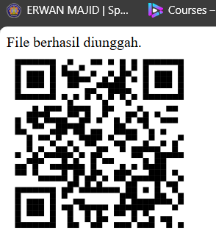

- echo "<img src='$targetfile' width='200' alt='Thumbnail'>";  
The src attribute of the img tag points to $targetfile, which is the path to the uploaded image.

The width='200' sets the width of the displayed image to 200px. By only setting the width, the height of the image will automatically adjust to maintain the aspect ratio of the original image.

The alt='Thumbnail' attribute provides alternate text for the image, which is useful for accessibility.

1. Save the file, open a browser and run localhost/week8/form_upload.php Select a file with an extension of .txt, .pdf, .doc, or .docx that is more than 5 MB in size. Click the Submit button. Observe what happens and record your understanding. (Question No. 6)

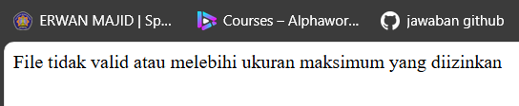

- it displays "File tidak valid atau melebihi ukuran maksimum yang diizinkan",because the file does not meet the size criteria,in code it says max is 3mb



1. Next run localhost/week8/form_upload.php again. Select a file with the extension .txt, .pdf, .doc, or .docx that is less than 3 MB in size. Click the Submit button. Observe what happens and record your understanding. (Question No. 7)

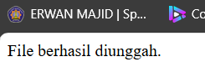

- it displays "File berhasil diunggah ",because the file meet the size criteria which max is 3mb ,my file 1 mb and type criteria which pdf

* **Practical Section 2. Multi Upload File**

1. Save the file, open the browser and run localhost/week8/form_multiupload.php. Select multiple files at once to upload. What do you understand from the script in the file? Record your understanding. (Question No. 8)

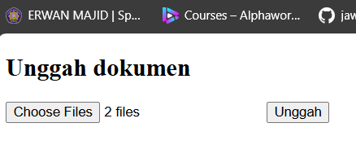

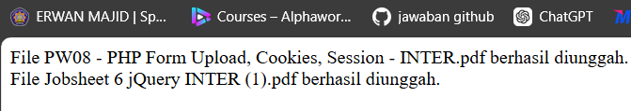

- Handling the Uploaded Files:

if ($_FILES['files']['name'][0]): Checks if there is at least one file uploaded.

$totalFiles = count($_FILES['files']['name']);: Counts the total number of files uploaded.

This allows the script to manage multiple file uploads in a single form submission.

Looping Through the Uploaded Files:

for ($i = 0; $i < $totalFiles; $i++): Iterates through each uploaded file.

$fileName = $_FILES['files']['name'][$i];: Retrieves the name of each uploaded file.

$targetFile = $targetDirectory . $fileName;: Sets the destination path for each file by combining the target directory (documents/) and the file name.

1. Change the code for multi upload of images. Screen shoot the code changes and provide an explanation of the code. (Question No. 9)

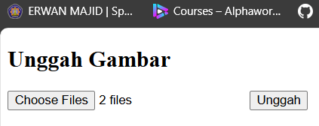

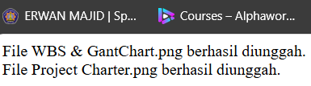

- The $targetDirectory is set to "images/", indicating that images will be stored in the images/ folder

- An array $allowedExtensions is used to specify allowed image file types (jpg, jpeg, png, gif).

- it make When the user selects multiple image files using the file input and submits the form, the selected files are sent to proses_upload.php.

For each file, the script checks if it is a valid image type and attempts to move it to the images/ directory.

A success message is displayed if the upload is successful, and an error message is displayed if the file is of an invalid type or if the upload fails for any reason.

* **Practical Section 3. Upload Files with PHP and Jquery**

1. Observe what is happening and explain your understanding. (Question No. 10)

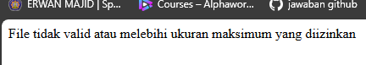

-Because max file is 3mb

Upload .docx files with a size of < 2 MB.

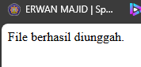

1. Change the code to be able to do multi-upload image files. Screenshot the code changes and explain the code. (Question No. 11)

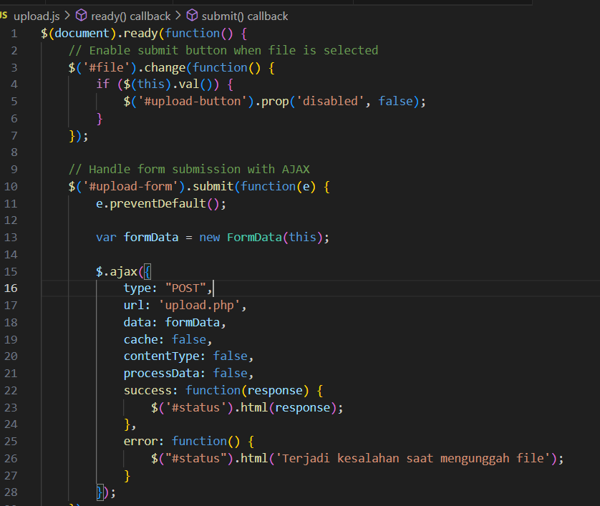

* **Practical Section 4. Decorate Upload Files**

1. Save the file. Open a browser and run localhost/week8/form_upload_ajax.php.

What do you understand from the program code above? Record your understanding. (Question No. 12)

- 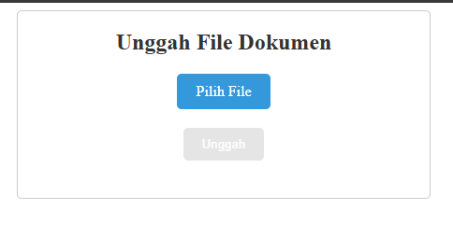

-make style

* **Practical Section 5. Creating Cookies**

1. Observe and explain your observations (Question No. 13)

-error it cause The first time you run the code, the $_COOKIE['user'] will not be set yet, so nothing will display from the echo statement.

After you reload the page or access it again, the user cookie will be set to Polinema, and the next time you visit the page, it will display the value Polinema.

1. Observe and explain the results displayed (Question No. 14)

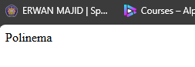

setcookie("user", "Polinema", time() + 3600); sets a cookie named user with the value Polinema, which will expire after one hour (3600 seconds).

On the first load, the cookie is set but not yet available until the next request.

On the second page load, $_COOKIE['user'] is accessible, and it will display "Polinema.

1. Observe and explain the results displayed. (Question No. 15)

If the cookie has expired, it will be reset, and nothing will display initially until you refresh the page and the cookie is set again

* **Practical Section 6. Deleting the Value of Cookies**

1. Observe and describe the results from steps 2 and 3, then draw conclusions. (Question No. 16)



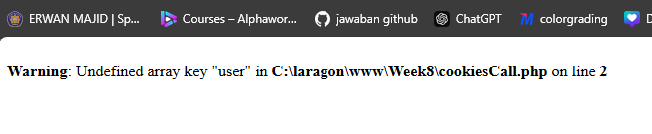

-it error because it delete cookies. deletes the user cookie by setting its expiration time to one hour in the past (time() - 3600).

**Practical Section 7. Application of Cookies to the Shopping Cart Feature**

1. Observe and explain the results displayed. (Question No. 17)

- 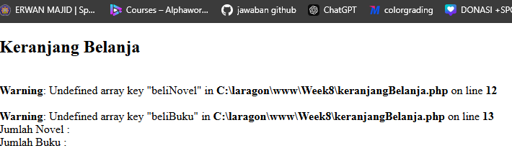

-it because cookies is no exist

1. Observe and explain the results displayed. (Question No. 18)

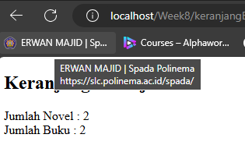

- it retrieves the values of two cookies: beliNovel and beliBuku.

Then, it echoes the number of novels (beliNovel) and books (beliBuku) stored in the cookies.

1. Observe and explain the results displayed. (Question No. 19)

-Since cookies are stored in the browser, they should persist even after you close and reopen the browser unless:

The cookies are set to expire after 60 seconds. After setting the cookies, it redirects the user to keranjangBelanja.php, where the items in the cart will be displayed.

* **Practical Section 8. Creating a Session**

1. Observe and explain the results displayed (Question No. 20)

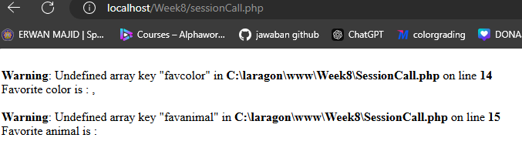

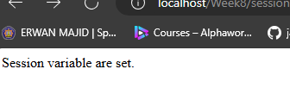

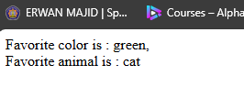

- After setting the session in sessionCreate.php, you should see the session variables displayed when you access sessionCall.php.

If you try to access sessionCall.php before running sessionCreate.php, there would be no session data set, and you may see an error or undefined values, depending on how PHP is configured to handle missing session variables.

* **Practical Section 9. Removing Session Values**

1. Observe and explain the results displayed. (Question No. 21)

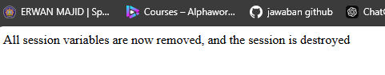

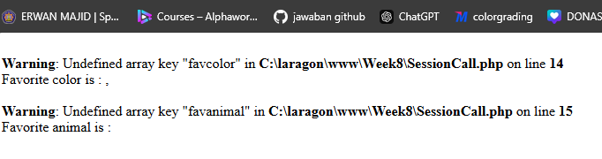

- session Handling: The code uses session_unset() to free all session variables and session_destroy() to destroy the session itself.

* **Practical Section 10. Implementation of Session on the Login Feature**

1. Observe and explain the results displayed (Question No. 22)

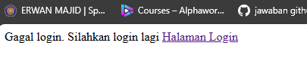

when you enter the username as admin and the password as 0000 and click "Log in":

The sessionLoginProcess.php script will receive the POST request.

The script checks the provided credentials against the hardcoded values:

Username: admin

Password: 1234

Since the provided password (0000) does not match the expected password (1234), the login fails.

1. Observe and explain the results displayed (Question No. 23)

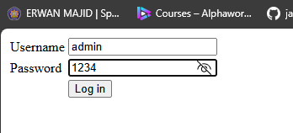

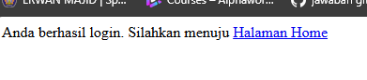

-it success because match Username: admin

Password: 1234

1. Describe the sequence of the process from login to logout (also mention the order in which

the files are processed) (Question No. 24)

- sessionLoginForm.html:

The initial form is displayed to the user.

-sessionLoginProcess.php:

Processes the login attempt and checks credentials.

-homeSession.php (if login is successful):

Displays the welcome message and log-out link.

-sessionLogout.php (upon logging out):

Ends the session and confirms logout.

The login to logout process begins with the user accessing sessionLoginForm.html, where they enter their username and password. Upon submission, the form data is sent to sessionLoginProcess.php, which verifies the credentials. If the login is successful, the user is redirected to homeSession.php, where a welcome message is displayed along with a logout link. If the login fails, a failure message prompts the user to try again. When the user clicks the logout link, they are directed to sessionLogout.php, which destroys the session and confirms that the user has logged out. This sequence illustrates how user actions drive the flow between these PHP files while managing session state effectively.